**NewsJacker Email – Engagement Series**

The purpose of these emails is to connect your buyer and sellers to a timely, relevant newsworthy item, positioning it alongside of an established and trusted brand (news source). You keep your service top-of-mind and show that it is the answer to the issue at hand, or that it solves a problem, etc.

**NOTE: The TubeJacker emails can also be adapted to work for NewsJacker campaigns. Just replace a news article with a YouTube article...the effect is the same.**

Subj: According to [PERSON IN NEWS ARTICLE] [RELEVANT NEWS]…

EXAMPLE: According to Dr Housing Bubble, real estate is overpriced…

Subj: [News Source] LOVE/HATES [TOPIC]

EXAMPLE: CNN LOVES First-time homebuyers?

Hey [FIRSTNAME],

…did you know that [RELATE NEWS STORY TO PRODUCT/INDUSTRY ie: “home prices in California has went over 15% from all time high when we had the last crash?”]?

Check it out here:

[LINK TO NEWS ARTICLE]

So what does that mean for you?

Well, you can either:

1) [OPTION 1 - SOMETHING NOT APPEALING ie. “Not sell your home if you believe the market will go down”]

2) [OPTION 2 - ACTION RELATED TO YOUR PRODUCT ie “cash out now before it goes down”]

...in fact, you can [SOME RELEVANT ACTION TO PRODUCT ie. “schedule a consultation with me so I can review how much your home is worth] now!

Get started now:

[LINK TO SCHEDULER OR TEXT ME TO SCHEDULE A CALL]

To your success,

NAME

Our Example: Sellers

SUBJECT: BIG NEWS: Orange County Housing prices at ALL-TIME High …

[SCREENSHOT/LINK TO 3RD PARTY ARTICLE]

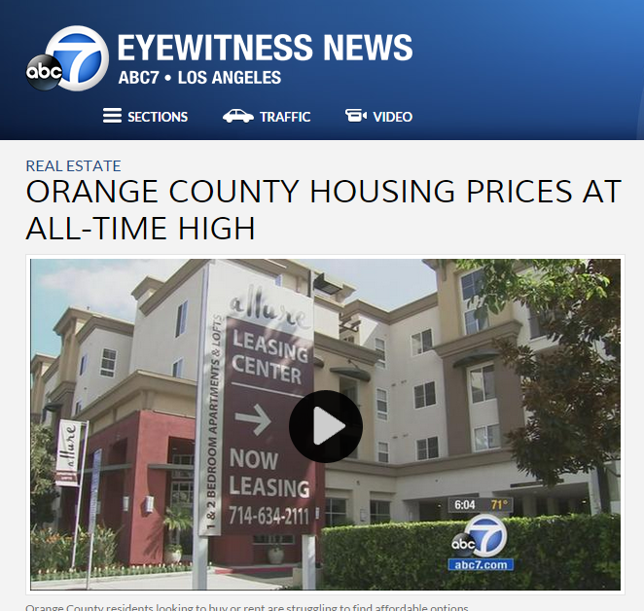

Hey,

Did you hear the news?!

First it we had a crash…

Then it we saw prices rebound…

Now real estate in Orange County is at an ALL-TIME HIGH!

LINK TO 3RD PART ARTICLE

This is HUGE for sellers because we haven’t seen this type of prices since 2007.

That's the good news.

The BAD NEWS is that if you want to cash out but miss the chance you can see your equity disappear really fast.

Fortunately, real estate is at a local level and different zip codes in Orange County get affected differently. I do consultation on home values with clients who are interested to sell by giving them the “real value” on what their home is worth.

Want to know who much your home is worth?

Text me at xxx-xxx-xxxx for a free consultation.

This is how I help sellers make the right decisions in 2014 and beyond…

...it's time to contact a local real estate expert in Orange County.

Talk soon,

Your Agent

P.S. Want to find out what your home is really worth?

Text me at xxx-xxx-xxxx for a free consultation.